Competitive Shooters of Lake Norman USPSA May 21st, 2026
COURSE DESIGNER: Ike Starnes

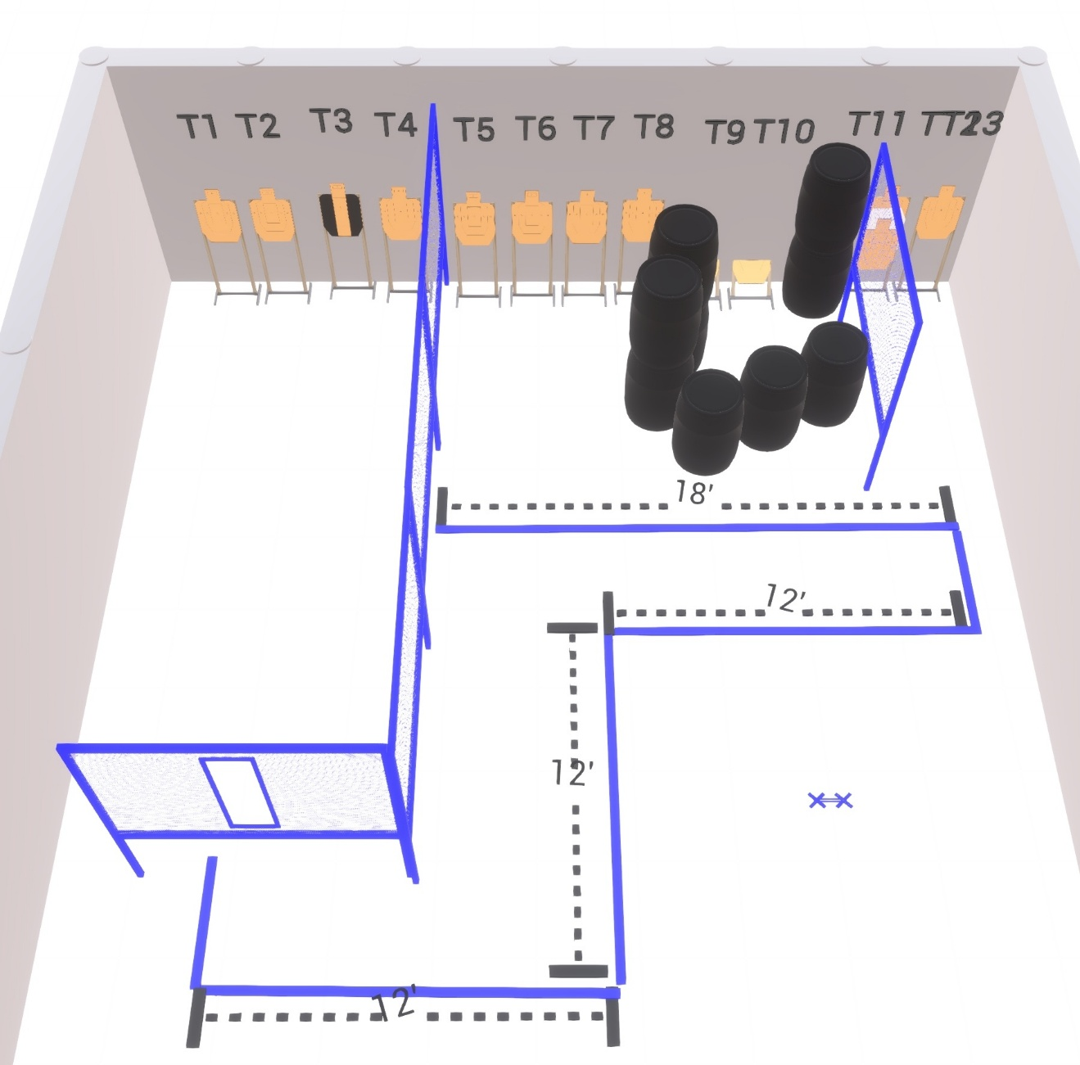

Stage 4 – Blue Bonnet
130-point Comstock course.
There are 13 paper targets. Start position is both feet on Xs.
Handgun is loaded and holstered with wrists below belt.
PCC is loaded and held in both hands with stock touching belt.

